**Software Requirements Specification**

**for**

**Pharmacy Management System**

**Prepared by ,**

**Nishanth.B**

**Naveen Kumar.A**

**Shireesh.V**

**NITK Surathkal**

**17-Jan-2018**

**Table of Contents**

**Table of Contents** [**ii**](https://docs.google.com/document/d/11LM0Kb6FxS-jRpMb2emFYhHHZ40F0OW0zM_ADt3IJ4I/edit#heading=h.ihv636)

**Revision History iii**

**1. Introduction 4**

1.1 Purpose 4

1.2 Document Conventions 4

1.3 Intended Audience and Reading Suggestions 4

1.4 Product Scope 4

1.5 References 4

**2. Overall Description 5**

2.1 Product Perspective 5

2.2 Product Functions 5

2.3 User Classes and Characteristics 7

2.4 Operating Environment 14

2.5 Design and Implementation Constraints 14

2.6 Assumptions and Dependencies 14

**3. External Interface Requirements 15**

3.1 User Interfaces 15

3.2 Hardware Interfaces 15

3.3 Software Interfaces 15

3.4 Communications Interfaces 15

**4. System Features 16**

4.1 System Feature 1 16

4.2 System Feature 2 17

4.3 System Feature 3 17

4.4 System Feature 4 18

**5. Other Nonfunctional Requirements** [**1**](https://docs.google.com/document/d/11LM0Kb6FxS-jRpMb2emFYhHHZ40F0OW0zM_ADt3IJ4I/edit#heading=h.2zbgiuw)**9**

5.1 Performance Requirements [1](https://docs.google.com/document/d/11LM0Kb6FxS-jRpMb2emFYhHHZ40F0OW0zM_ADt3IJ4I/edit#heading=h.2bn6wsx)9

5.2 Safety Requirements [1](https://docs.google.com/document/d/11LM0Kb6FxS-jRpMb2emFYhHHZ40F0OW0zM_ADt3IJ4I/edit#heading=h.1egqt2p)9

5.3 Security Requirements [1](https://docs.google.com/document/d/11LM0Kb6FxS-jRpMb2emFYhHHZ40F0OW0zM_ADt3IJ4I/edit#heading=h.3ygebqi)9

5.4 Software Quality Attributes 19

**6. Other Requirements 20**

**Appendix A: Glossary 20**

**Appendix B: Analysis Models 20**

**Appendix C: To Be Determined List 20**

**Revision History**

|  |  |  |  |
| --- | --- | --- | --- |
| **Name** | **Date** | **Reason For Changes** | **Version** |
| B.Nishanth | 17-01-2019 | Initial Version | 1.0 |
| V.Shireesh | 24-01-2019 | Added operating environment and external interface requirements | 1.1 |
| A.Naveen | 31-1-2019 | Added System features and other non functional requirements | 1.2 |
| All group members | 21-2-2019 | Formatted and modified the document wherever required | 1.3 |

# **Introduction**

## **Purpose**

This project is to create a technical solution that satisfies the functional requirements for the employees of a pharmacy.

The pharmacy management system is built for the sake of ensuring effective and clear data saving and manipulating as well as neat work on the pharmacy medical products.

This refers the pharmacy management system project highly minimize time and resource by which, searching the medicine data you can get the data in quickest time. The other thing is for storing data in secure way.

## **Document Conventions**

The followings are the list of standards and typographical conventions that used in thisSRS document.

Main Section

TitlesFont: Times New Roman Face: Bold Size: 16

Subsection

TitlesFont: Times New Roman Face: Bold Size: 14

Other Text Explanations

Font: Times New Roman Face: Normal Size: 12

Table and image figure Explanations

Font: Times New Roman Face: Italic Size: 12

## **Intended Audience and Reading Suggestions**

Developers for third party services and government officials*.*

## **Product Scope**

With the development of specific and potent synthetic drugs, the emphasis of the pharmacist’s responsibility has moved substantially towards the utilization of scientific knowledge in the proper use of modern medicines and the protection of the public against dangers that are inherent in their use.

Pharmacists are employed in regulatory control and drug management, community pharmacy, hospital pharmacy, the pharmaceutical industry, academic activities, training of other health workers, and research. In all these fields, their aim is to ensure optimum drug therapy, both by contributing to the preparation, supply and control of medicines and associated products, and by providing information and advice to those who prescribe or use pharmaceutical products.

**1.5 References**

https://web.cs.dal.ca/~hawkey/3130/srs_template-ieee.doc

# **2.Overall Description**

## **2.1 Product Perspective**

Our main objective is to provide a user friendly application to the employee working in a pharmacy and take of his burden of remembering details of every drug in the pharmacy. Our other objective is to attract the customers towards our pharmacy by providing customers with discounts.

In Pharmacy Management System, administrator has a Login ID and Password. Also all the users have different permission rights to access the applications.

There are two main roles in the system. Admin and employee. Admin has complete access to the whole system, while employee is the role that is responsible for the use of the system.

## **2.2 Product Functions**

**Register Module:**

Registration of new employees is done through this module. Here we enter the details new employee and they get stored in the database.This module is operated by Admin only.Admin is only authorized to register new employees and he provides login credentials to the employee.

**Login Module:**

Employee logs into his account using this module. Here every employee need to type his/her login credentials in order to enter into his account.

**Home Module:**

Employee gets into this module after logging in.This module contains four sections namely billing, history, add drugs, search. And employee can access these sections.

**Add new patient Module:**

This module provides a patient id to the new customer and stores their details in the database.

**Create bill Module:**

Based on the prescription provided by the customer employee add drugs to the bill and generates the bill and issues the receipt to the customer.

**Bill calculation Module:**

This module calculates amount in the bill based on the drugs and quantity of drugs customer has taken. And also Discount is given to the customers based on his/her previous bill amounts.

**Search by drug name Module:**

This module is used to search for a particular drug and lookup its stock, functionality, side effects, shelf number and price. Employee can also see the list of past few bills which contains this drug.

**Search by patient_id Module:**

This module is used to search for a particular patient based on his ID and lookup his previous billing details and the pharmaceuticals he/she has taken from our pharmacy.

**Search by bill_id Module:**

This module is used to search for a particular bill based on its ID and can get complete list of drugs in that bill and name of employee who issued that bill and the details of patient who has taken the pharmaceuticals and the amount in the bill.

**History Module:**

This module provides the list of bills billed by different employees in the pharmacy.And the

employee can look into any bill.

**Add Drug Module:**

This module is used for addition of new drugs or can increase the stock of an existing drug in

the pharmacy.Once the employee updates this module the database will get updated

Accordingly.

**Profile Module:**

This module contains the details of the employee such as his/her name,phone number,email id.

It also contains the bills issued by that employee.

**Edit Profile Module:**

The employee can edit his/her details like username,email etc.. in this module.

**Change Password Module:**

The employee can change his/her password in this module.

**Logout:**

The employee can log out of the session through this module.

**2.3 User Class and characteristics**

**Class Diagram**

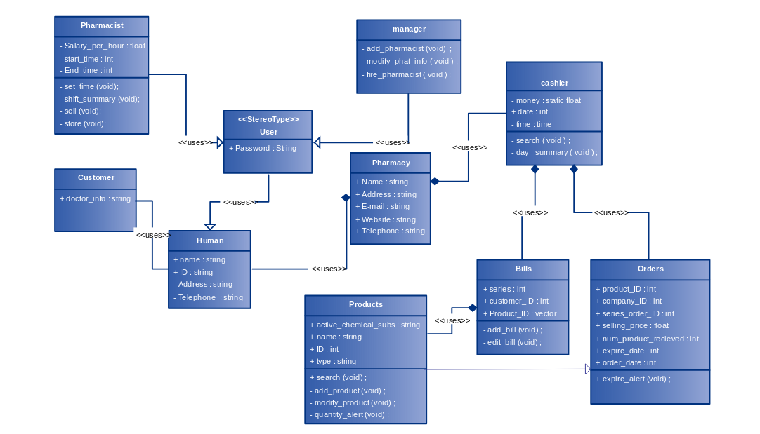

**Sequence Diagrams for different functionalities**

1. **Login**

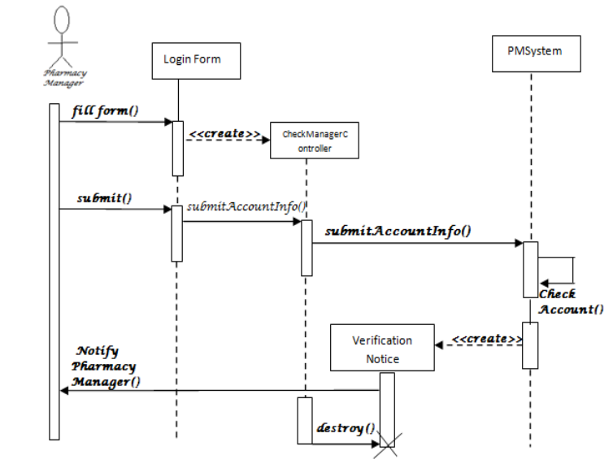

**b. Add Medicine**

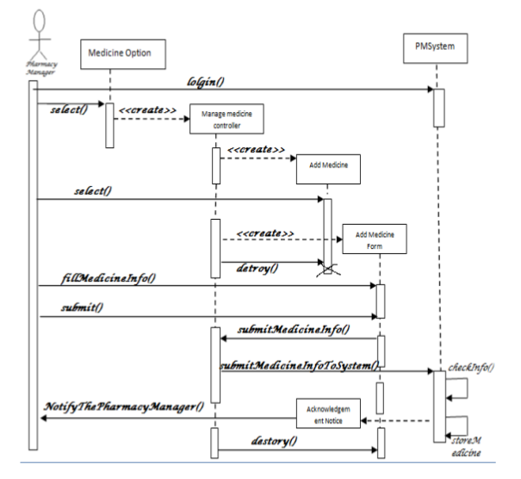

**c. Update medicine data**

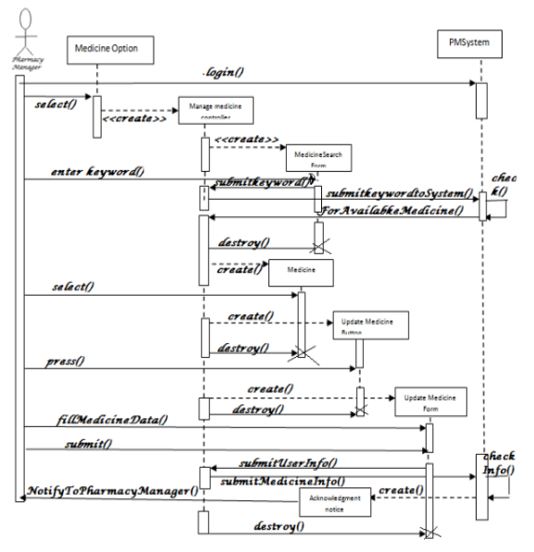

**d. Search medicine**

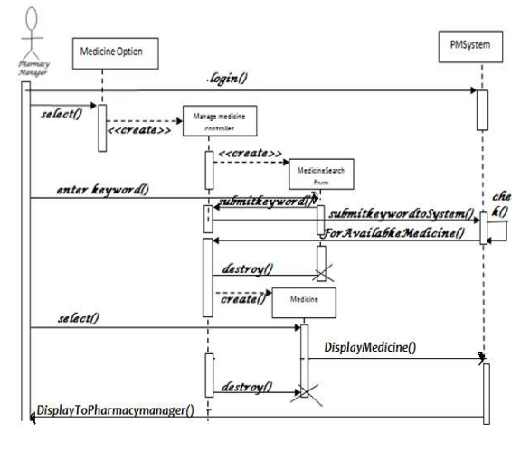

**ER Diagram**

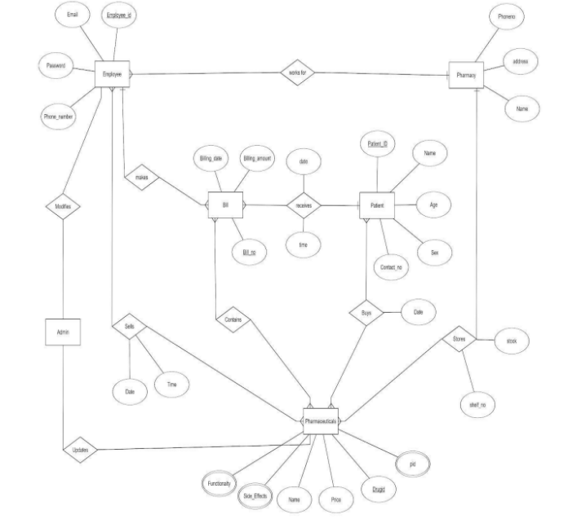

**Use Case model**

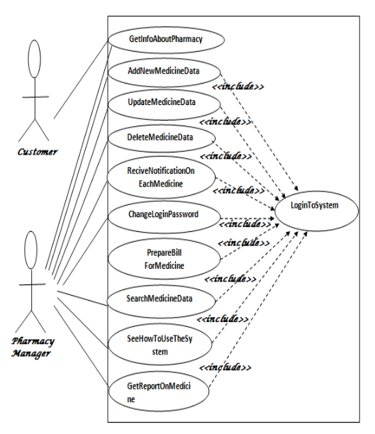

## **2.4 Operating Environment**

Hardware Requirements:

* Computer Machine with at least 2GB RAM and 32GB ROM
* External Disk
* Database at least 10 GB large for long run use of this application
* Reliable web server

Software Requirements :

* Xampp (Mysql)
* Composer
* Operating system : Windows XP or above
* Languages used : PHP,HTML,Javascript

## **2.5 Design and Implementation Constraints**

The project is developed using HTML,JavaScript,PHP on the back hand for database we are using Mysql server. This product is accomplished with the login facility for the employee and admin.

## **2.6 Assumptions and Dependencies**

This software is dependent to pharmaceutical information database. It assumes that it is compatible with PHP 5.6 and any future updates . We cannot add a drug which is already present in the database with new functionality/side effects . A customer cannot buy pharmaceuticals more than the quantity available.

# **3. External Interface Requirements**

## **3.1 User Interfaces**

* Login
* Create Bill
* Search by drug name,patient id,bill id
* Add Drug
* Logout

## **3.2 Hardware Interfaces**

The system shall run on Microsoft Windows based system.

## **3.3 Software Interfaces**

The system shall interface with Access database.

## **3.4 Communications Interfaces**

No communication interfaces as our system is not connected with internet.

**4.System Features**

## **4.1.Secure login to the interface**

**4.1.1 Description and Priority**

Secure login to the interface is a primary system feature which enables the privacy and security to the data of the pharmacy.It is of high priority.

**4.1.2 Stimulus/Response Sequences**

The pharmacy employee provides his unique username and password for which we verify the correctness of the data from database.To ensure secure login,the password is encrypted and stored.Use of CSRF token enables high security so that the same url cannot be opened in private browsing etc.

**4.1.3 Functional Requirements**

The login screen allows registered users to login to the site to access all of the features that their account gives them access to. If they type in their username and password and click submit the users credentials are validated and if correct they are logged in.If they are incorrect they get an error message.If the user has forgotten their password they click "Forgot Password?" which takes them to a password recovery screen. If the user does not have an account then they click the register button.Some of the functional requirements for secure login are

**Cryptographic Support (FCS) :** What operations use cryptography, what algorithms and key sizes are you using, and how are you managing their keys (including distribution and destruction)?

**Privacy (FPR) :** Need to support anonymity, pseudonymity, unlinkability, or unobservability. There conditions where you want or don’t want these (e.g., should an administrator be able to determine the real identity of someone hiding behind a pseudonym?). Note that these can seriously conflict with non-repudiation, if you want those too. If you’re worried about sophisticated threats, these functions can be hard to provide.

**4.2 Add a drug**

**4.2.1 Description and Priority**  
The add a drug function allows an employee to add a new drug into the pharmacy management system specifying its details and also he/she can update its stock,details etc

**4.2.2 Stimulus/Response Sequences**  
Adding a drug inserts a new drug into the database and is made available for purchase if in stock.

**4.2.3 Functional Requirements**  
REQ-1: The employee is required to enter the details of the drug with stock if he is adding a new drug.If the employee is updating the old drug,he should not enter a different side effect of the drug from previous one.  
REQ-2: If so,the employee is notified about it that he entered wrong functionality or side effect.

**4.3 Search by drug name,patient id,employee id**

**4.3.1 Description and Priority**  
The search function allows a user to search for events and classes by category or keyword(drug name or patient id or employee id here)

**4.3.2 Stimulus/Response Sequences**  
A search can be entered into the text box on the screen after selecting which mode of search the user intends to use.

**4.3.3 Functional Requirements**  
REQ-1: The search will use the term as entered by the user and find the related data and displays on the screen.  
REQ-2: The user will be notified if there are no results returned.

**4.4 Buy a medicine**

**4.4.1 Description and Priority**  
The buy a medicine function allows a patient to to buy a drug.

**4.4.2 Stimulus/Response Sequences**  
As a result the stock is updated in the database if the patient buys the medicine and also a bill is generated and is recorded.

**4.4.3 Functional Requirements**  
REQ-1: The patient is required to enter patient id and the names of drugs he/she is willing to buy.  
REQ-2: If the medicine is out of stock or the medicine is not available in the pharmacy the corresponding message is shown.

# 

# 

# 

# 

# 

# 

# 

# **5.Other non-functional Requirements**

# **5.1** **Performance Requirements**

The only requirement is that the user and software can interact in a reasonable amount of time.

**5.2 Safety Requirements**

There are no safety requirements.

## **5.3 Security Requirements**

The user’s information will be password protected and accessible only to them.

## **5.4 Software Quality Attributes**

This software is versatile through its open source capabilities to eliminate bugs and improve performance.

# **6.Other Requirements**

**Appendix A: Glossary**

*Pharmacy Management System* : A computer system that stores the data and retrieves the necessary information according to the user needs.

*Pharmacy Employee* : A worker working in the pharmacy.

*Use Case* : An action implemented by the user system.

*Scenario* : A short text description on the system function

**Appendix B: Analysis Models**

Different analysis models such as class diagram,sequence diagrams have been included above.

**Appendix C: To Be Determined List**

*<Collect a numbered list of the TBD (to be determined) references that remain in the SRS so they can be tracked to closure.>*